Bangladesh Army University of Engineering & Technology (BAUET)

Qadirabad, Natore-6431

**Department of**

**Computer Science and Engineering (CSE)**

**Project Proposal**

**Course Code:** CSE-3104

**Course Title:** Software Engineering and Information System Sessional

**Submission Date:** 03-11-2022

|  |  |
| --- | --- |
| **Submitted By** | **Submitted To** |
| **Name:**  Fahmida Rahman Moumi | Md. Nazmus Salehin |
| **ID:** 20104001 | Lecturer |
| **Name:**  Md. Tanvir Ahmed Tagim | Dept. of CSE, BAUET |
| **ID:** 20104007 |  |
| **Name:**  Amrin Nahar | Mst. Irin Sultana |
| **ID:** 20104009 | Lecturer |
| **Name:** Gourob Roy | Dept. of CSE, BAUET |
| **ID:** 20104027 |  |
| **Name:**  Mst. Bilkis Khatun |  |
| **ID:** 20104031 |  |
| **Name:** Md. Arik Rayhan |  |
| **ID:** 20104033 |  |
| **Department:** CSE |  |
| **Batch:** 11th |  |
| **Session:** 2020-2021 |  |

**Project Title:** BAUET Result System

**1.****Explanation of some existing system:**

The traditional result of BAUET works by manually creating the result of each student.The students’ results are generated through a spreadsheet application and then printed on a paper, attached to a wall for declaration and then stored. The process is that teacher take marks of each student based on OBE curriculum and then manually calculate the results of each student. Then their result is stored in a spreadsheet and given to the account office. Moreover, BAUET follows OBE based curriculum which is follows these rules: The total performance of a student in a given course is based on a scheme of continuous assessment. For theory course this continuous assessment is made through a set of quizzes, class tests, observations/ class participation and class attendance, homework assignment and a semester final examination. The assessment in laboratory courses is made by evaluating performance of the student at work during the class, viva-voce during laboratory hours and quizzes. Each course has a certain number of credits, which describes its corresponding weightages. A letter grade with a specified number of grade points is awarded in each course for which a student is registered. A student's performance is measured by the number of credits completed satisfactorily and by the weighted average of the grade points earned. A minimum Grade Point Average (GPA) is essential for satisfactory progress.[3] A minimum number of earned credits also have to be acquired in order to qualify for the degree. Letter grades and corresponding grade points will be awarded in accordance with the provisions (as per University Grant Commission-UGC grading system).[1] One of the popular university in Bangladesh is DIU so here we are addressing their result system. In addition to class work, home assignments, term papers, project works, case studies, quizzes and weekly tests. There are three compulsory examinations in each semester for each course such as First Term, Mid-Term and Final Examination. The grade shall be determined and given by the teacher who is responsible for the course, according to overall performances in all the examinations.[2]

**2. Scope of our works:**

We plan to develop this project by using this will reduce the need for human resources and save a lot of time. The purpose of the BAUET Result system is to automate the existing manual system with the help of computerized equipment and full-fledged computer software, fulfilling their requirements valuable data information can be stored for a longer period with easy accessing and manipulation of the same. The required software and hardware are easily available and easy to work with. Student Result System, as described above, can lead to an error-free, secure, reliable and fast system. It can assist the user to concentrate on their other activities rather than on record keeping. Thus, it will help the organization in better utilization of resources. The organization can maintain computerized records without redundant entries. That means that one need not be distracted by information. Student Result web System, as described above, can lead to an error-free, secure, reliable and fast management system. It can assist the user to concentrate on them rather than on record keeping. Thus, it will help the organization in better utilization of resources. The organization can maintain computerized records without redundant entries. That means that one need not be distracted by information that is not relevant while being able to reach the information. The main objective was to enhance and automate the management and declaration of students’ results using a computerized system. A well-defined, efficient, controlled and managed information system or software based on web technology storing, processing and providing information through the internet.

**3. Methodology:**

Step 1: At first User have to enter the website.

Step 2: Then user have to login.

Step 3: Then the system will check if the user is Teacher or Student

Step 4: The teacher will be able to modify marks and subject and profile

Step 5: The user will be able to view result and modify profile

Step 6: Then they will exit

**4. Use Case Diagram:**

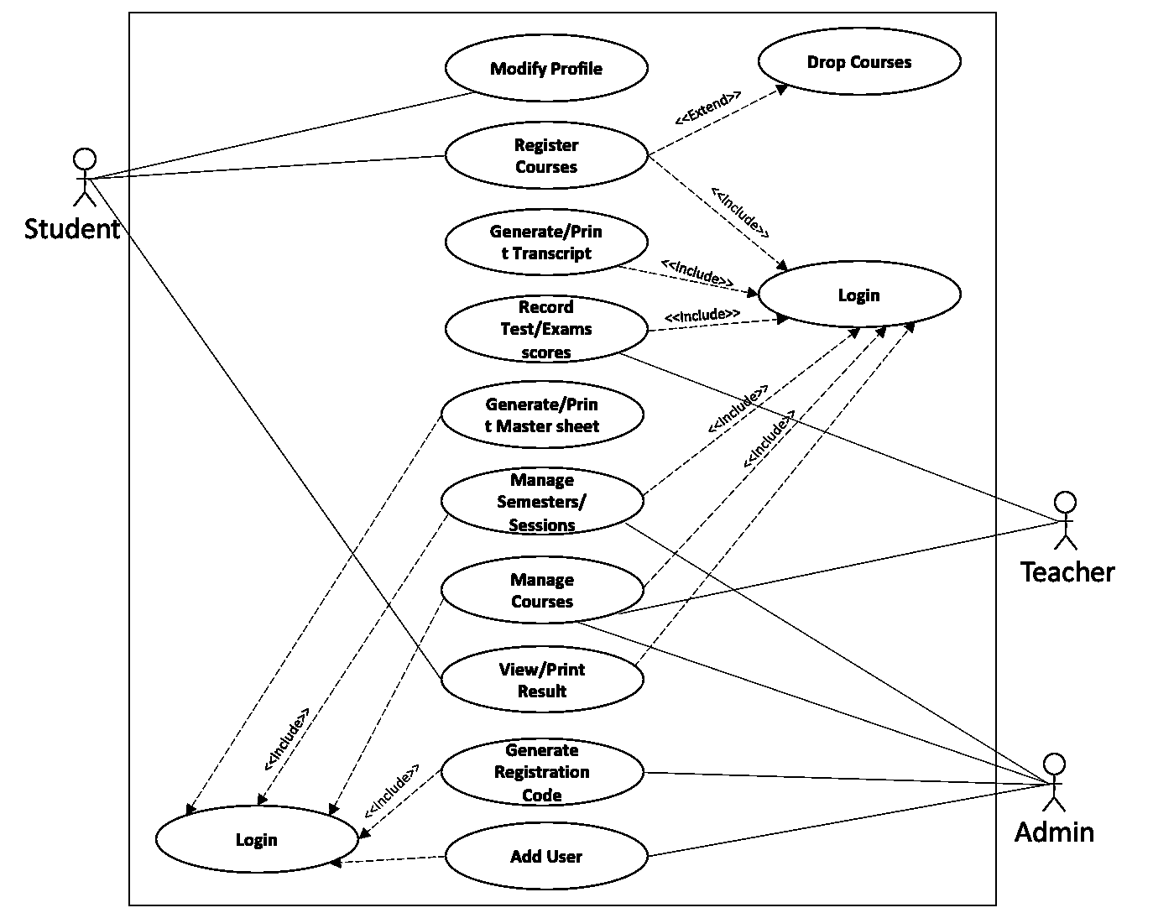

**Figure 1:** Use case Diagram for BAUET Result System

**5. Requirements of your proposed models for the development:**

1. Web Developer
2. Software:

* Xampp
* Notepad/Notepad++
* Dreamweaver

1. Personal Computer
2. Internet
3. Programming Language:

* HTML
* CSS
* Java Script

**6. Discussion:**

From a proper analysis of positive points and constraints on the component, it can be safely concluded that the product is a highly efficient BAUET Result system was developed using JavaScript’s and MYSQL as the side-server and HTML and CSS as the client-side. The database used in the BRS was designed with MYSQL Database Management System (DBMS). All the information pertaining to the BRS are stored in the system database.

**6.1** **Advantage of BAUET Result System:**

For Management:

1. With student result management system, teachers, professors, and staff can create result analysis reports.

2. Gradebook Management.

3.Exam Timetable Management.

4. Records marks and result on a single database.

5. Add & manage students and Declare Results.

6. Integrate-able with fee management.

7. Send/ publish results to parents and students online.

8. Record and search details of every exam/test, student wise/course wise.

9. Admit Card/ Hall Ticket Generation.

10. Calculate scores, percentages and grades.

For Students:

1. Download report of the results in PDF format.

2. View results of tests and exams online.

3. Search test and exam scores with valid Roll number/ ID.

4. View Semester Results for all Subjects from anywhere using smart devices.

5. Request for re-evaluation.

**6.2 Disadvantages of BAUET Result System:**

1. The student result management system is prone to hacks.

2. Administration cannot edit or modify scores after the deadline.

3. Extensive modules and features make it difficult for a user to utilize the application.

4. Minor technical glitches and issues.

**7. Conclusion:**

BAUET Result System is an online website and can be used at any place, any time and by any student or faculty. This application will avoid the calculation and simplify the process of visualizing results by students as well as faculty. The main objective was to enhance and automate the management and declaration of students’ results using a computerized system. A well-defined, efficient, controlled and managed information system or software based on web technology storing, processing and providing information through the internet.

**8. References:**

|  |  |
| --- | --- |
| [1] | “Explanation of some existing system” [Available on Online] [https://bauet.ac.bd/w p-content /uploads/](https://bauet.ac.bd/w%20p-content%20/uploads/)2020/12/Examination-policy-.pdf, 12 September 2022 |
| [2] | “Explanation of some existing system” [Available on Online] https://bscincse.word press.com/grading-system/, 17 August 2022 |
| [3] | “Explanation of some existing system” [ Available on Online] https://www.astesj.c om/v05/i03/p15/, 31 July 2022 |